XISD6329
FORMATIVE 1
TASK 1
SITE MAP, WIREFRAMES & PROJECT PLAN UPDATE SUMMARY
Literacy Programme Management System (LPMS)
Client: READ Educational Trust
Individual Submission - Formative 1, Task 1
Continuing the project originally developed by Team Point Blank (XISD5319):

Table of Contents
List of Figures 3
Client Needs / Requirements 4
Updated Project Plan Section 5
Website Sitemap 6
Mobile Application Sitemap 6
Website Wireframes 7
Mobile Application Wireframes 8
Deployed Website Link 8
GitHub Repository Link 8
References 9

List of Figures
Figure 1: DevOps Lifecycle - Team Point Blank / LPMS
Figure 2: Website Sitemap
Figure 3: Mobile Application Sitemap
Figure 4: Website Wireframes (Login, Dashboard, School Registration, Attendance)
Figure 5: Mobile Application Wireframes (Login, Sessions, Attendance, Progress)

Client Needs / Requirements
READ Educational Trust is a South African non-profit organisation that helps people in disadvantaged communities learn to read. The organisation runs reading projects in many schools, supports its teachers and coordinators, and monitors how learners take part and progress.
At the moment most of the organisation's work depends on manual or partly digital systems such as paper registers, separate spreadsheets and scattered files, leading to waste, duplicated records and poor reporting. Coordinators have no single overview of what is happening in every school, teachers struggle to log and find information on learners' progress, and managers are unable to create correct reports on time for donors and stakeholders. Also, there is no reliable way to track resources or check the impact of interventions.
To handle these needs, the Literacy Programme Management System (LPMS) uses one central website, now paired with a companion phone app for this work. In particular, the client wants the system to:
- Register and manage schools, teachers, and learners from a single interface.
- Create and schedule literacy programme sessions, and record attendance per session.
- Capture and track learner progress and assessment scores over time.
- Allocate and track resources (books, stationery, digital materials) per school.
- Generate programme activity, learner progress, resource allocation, and school summary reports, viewable on screen and exportable to PDF, for management and donors.
- Give teachers a lightweight, mobile-friendly way to record attendance and update learner progress while in the classroom, without needing a desktop browser.
The requirements from the Requirement Analysis Document (XISD5319) are still the same for this task, and the only update is a mobile app to cover the final need because teachers are the ones most likely to need the system away from a desktop.

Updated Project Plan Section

The complete revised Project Plan, covering both Requirements Analysis and System Design, was uploaded separately via the XISD6319 Doc Update link as instructed. I kept every section from the earlier XISD5319 submission and then checked, fixed, and revised the sections below to match the broader website and mobile requirements of this project.

What Was Updated
Milestones and Deliverables:
- We kept the original milestones for planning, analysis, design, development, testing and documentation, and added new ones for this Task 1 document, website development, mobile app development, integration and system testing, deployment, and final submission.
Work Breakdown Structure (WBS):
- We added new Website and Mobile App Development tasks, each listing how long it takes, what comes before it, and who is in charge, just like the original WBS.
Gantt Chart:
- The chart was redone to mark every XISD5319 phase from Project Planning to Documentation as done, and to add the new XISD6329 phases, Task 1, Website Development, Mobile App Development, Integration & System Testing, Deployment, and Final Documentation, stretched to November 2026.
Entity Relationship Diagram (ERD):
- Corrected and re-exported. The first ERD picture was cut off at the bottom, so the IsActive column for the User table didn't show up even though it was listed in the database design table. We've completely remade the ERD to line up with the written schema, now displaying all nine tables along with how they connect.
Other Relevant Artefacts:
- A DevOps Lifecycle was introduced for this task (Figure 1) - an eight-stage Plan → Code → Build → Test → Release → Deploy → Operate → Monitor cycle mapped to the tools already listed as available resources in the original Project Plan (Visual Studio, GitHub, web browser). This governs how website and mobile app development will proceed from here, rather than treating the build as a single one-off submission.
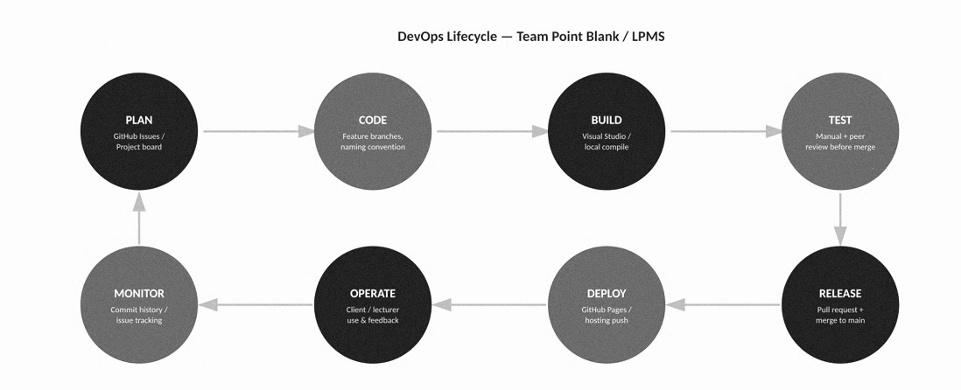
Figure 1: DevOps Lifecycle - Team Point Blank / LPMS

Why These Updates Were Needed
Task 1 expands LPMS from a web-only setup to a combined website and teacher-facing mobile app. We therefore revised the Milestones, WBS, and Gantt Chart to cover the extra build track, and used the chance to fix the ERD export bug noticed while assembling this submission. Functional requirements are unchanged, the client needs in the original Requirement Analysis Document still stand and are repeated in the Client Needs / Requirements section above.

Website Sitemap
The site map below is derived directly from the System Design Document's actor/function mapping (Administrator, Programme Coordinator, Teacher) and the nine-table database design from XISD5319.
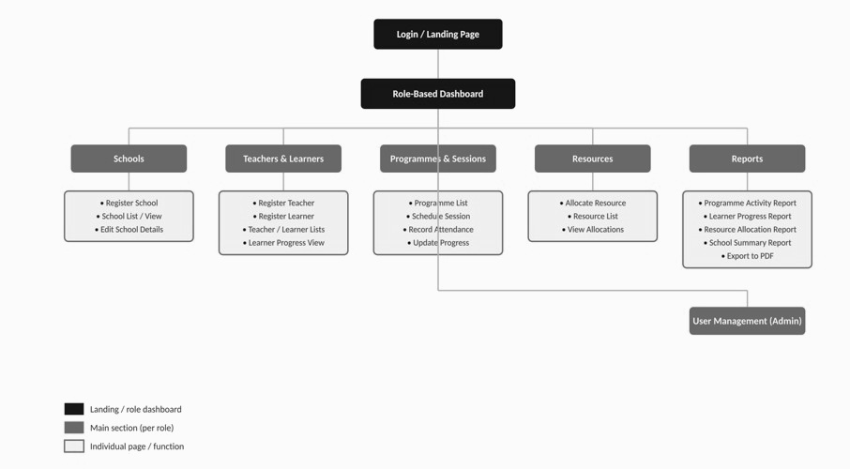
Figure 2: Website Sitemap

Mobile Application Sitemap
The mobile app is scoped to the Teacher role only, since Teachers are the actor most likely to need attendance and progress capture away from a desktop — in the classroom, during a session.
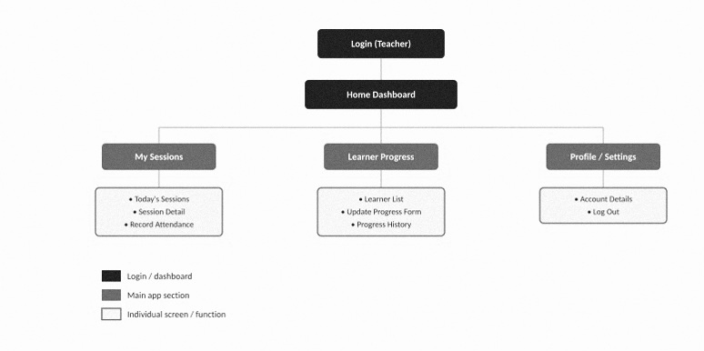
Figure 3: Mobile Application Sitemap

Website Wireframes
The wireframes below are low-fidelity layouts covering the highest-priority screens identified in the site map: authentication, the main dashboard, a representative registration form, and the attendance recording workflow that makes up the core of the LPMS.
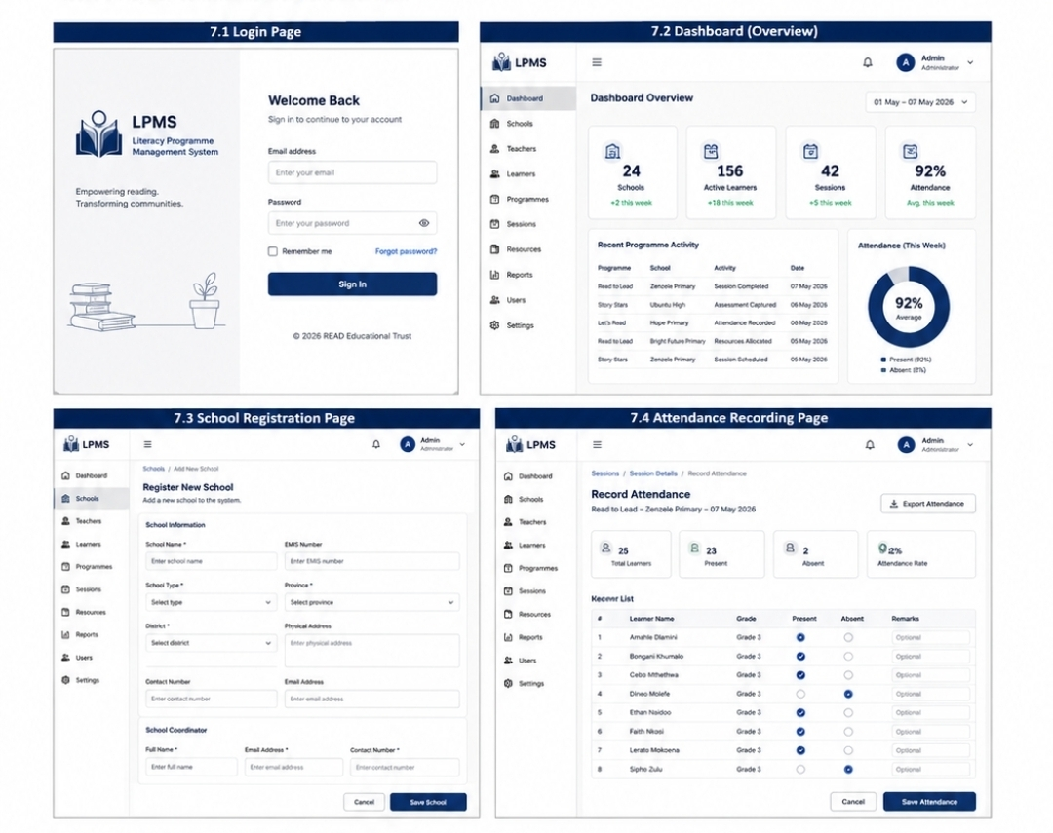
Figure 4: Website Wireframes - Login, Dashboard, School Registration, Attendance Recording

Mobile Application Wireframes
The phone wireframes are designed around teaching, so checking today's sessions, taking attendance, and updating student progress all take just two taps from the home screen.
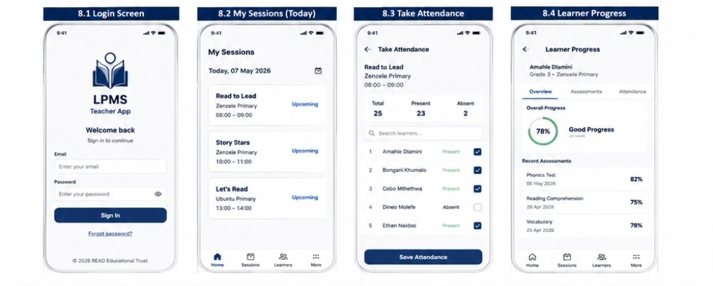
Figure 5: Mobile Application Wireframes - Login, Sessions, Attendance, Progress

Deployed Website Link
The website is deployed via GitHub Pages from the repository below:
Live site: https://github.com/Jxcob-Wxlly/lpms.git

GitHub Repository Link
The GitHub repository containing the HTML, CSS, JavaScript, images, and other project files used to develop the website:
Repository: https://github.com/Jxcob-Wxlly/lpms.git
The repository includes the shared stylesheet, per-page JavaScript, image assets (site maps, wireframes, DevOps lifecycle diagram), and a README describing the folder structure and how to run the site locally. Folder and file names follow the lowercase, hyphen-separated naming convention required for this task.

References
GitHub. 2026. GitHub Pages documentation. [online] Available at: https://docs.github.com/en/pages [Accessed 5 Sep. 2026].
Pressman, R.S. and Maxim, B.R. 2020. Software Engineering: A Practitioner's Approach. 9th ed. New York: McGraw-Hill.
Project Management Institute (PMI). 2021. A Guide to the Project Management Body of Knowledge (PMBOK Guide). 7th ed. Pennsylvania: Project Management Institute.
READ Educational Trust. 2026. About READ Educational Trust. [online] Available at: https://readsa.org.za/ [Accessed 10 Apr. 2026].
Sommerville, I. 2016. Software Engineering. 10th ed. Harlow: Pearson.
Team Point Blank. 2026. Project Plan - Literacy Programme Management System. XISD5319 submission. IIE Rosebank International.
Team Point Blank. 2026. Requirement Analysis Document - Literacy Programme Management System. XISD5319 submission. IIE Rosebank International.
Team Point Blank. 2026. System Design Document - Literacy Programme Management System. XISD5319 submission. IIE Rosebank International.

